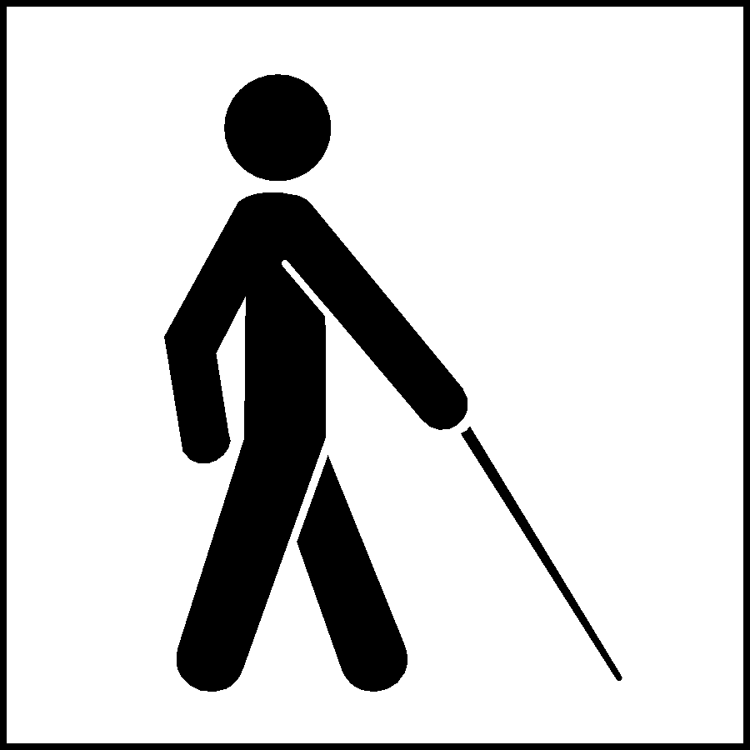
George Mason University

College of Education and Human Development

Special Education Program

Summer 2008

Characteristics of Students with Visual Impairments
EDSE 511/411 6V1
(1 Credit Hour)

Schedule

Class Time Tuesday 4:00 – 6:40

Instructor

Dr. Stacy Kelly
Phone: 847-814-0350
Email: skelly@afb.net

Office Hours: By Appointment (online)

Course Description

No prerequisites

Provides an overview of the characteristics of and services to persons with visual impairments, including the impact of visual impairment on infants’ and children’s growth and development, child and adolescent emotional and social development, and family interaction patterns. Considers the educational, conceptual, psycho-social, and physical implications of a visual impairment. Course delivered online.

Nature of Delivery

Learning activities in this class will include the following:

1. Class lecture, discussion, and participation via synchronous face to face, web-conferences or videoconferences

2. Video and other relevant interactive media presentations

3. Study and independent research

4. Application activities, including regular assignments

5. Written responses to posted discussion questions posted on Blackboard.
Relationship of Courses to Program Goals and Professional Organizations

This course is part of the George Mason University, Graduate School of Education (GSE), Special Education Program. This program complies with the standards for special educators established by the Council for Exceptional Children (CEC), the major special education professional organization.

The CEC Standards are listed on the following web site: http://www.cec.sped.org . Look in the second column on the left, and click on “Professional Standards.” On this page, to the right, there is a red book pdf document titled “What Every Special Educator Must Know.” The CEC Standards are located in this document. The primary CEC standard that will be addressed in this class will be Standard 2 on Characteristics of Learners.

CEC Special Education Content Standard #2: Development and Characteristics of Learners

Special educators know and demonstrate respect for their students first as unique human beings. Special educators understand the similarities and differences in human development and the characteristics between and among individuals with and without exceptional learning needs (ELN)^{1/}. Moreover, special educators understand how exceptional conditions can interact with the domains of human development and they use this knowledge to respond to the varying abilities and behaviors of individual’s with ELN. Special educators understand how the experiences of individuals with ELN can impact families, as well as the individual’s ability to learn, interact socially, and live as fulfilled contributing members of the community.

Beginning special educators demonstrate their mastery of this standard through the mastery of the CEC Common Core Knowledge and Skills, as well as through the appropriate CEC Specialty Area(s) Knowledge and Skills for which the preparation program is preparing candidates.

Required Text

Holbrook, C., Koenig, A. (Eds.). (2000). Foundations of education. (2nd Ed.) New York, NW: American Foundation for the Blind.

Learner Outcomes

Upon successful completion of this course, the participants will be able to:

- Demonstrate knowledge of the history of the education of persons with a visual impairment.
- Demonstrate knowledge of the terminology used in the field of working with persons with a visual disability.
- Demonstrate knowledge of the current trends in education of persons with a visual impairment.
- Demonstrate knowledge of the educational settings which provide education of persons with a visual impairment.
- Demonstrate knowledge of a variety of local, state, and national resources for services to persons with a visual impairment.
- Demonstrate basic knowledge of basic anatomy of the eye and eye diseases.
- Demonstrate knowledge of the impact of a visual impairment on a person’s physical, conceptual, academic, vocational and social development.
- Demonstrate knowledge of the legal rights of a person with a visual impairment.
- Demonstrate knowledge of the basic techniques for adapting and modifying instruction for a student with a visual disability.
- Demonstrate knowledge of the need for specialized instruction for certain persons with a visual disability, to include orientation and mobility, low vision aids, and technology.

Course Schedule:

Date | Topic | Readings & Assignments  (Assignment should be completed on the day they are listed Discussion topics are posted the day they are listed and due the following week. See rubric for specifics)
1/27/09 | Course Technology Review (Adobe Connect) Review of Syllabus and assignments  Historical Perspectives | Discussion Board Topic #1: Braille Literacy Posted today  Vol. I Chapter 1
2/3/09 | Basic Anatomy of the eye and conditions  Implications of Visual Impairment  Social Skills/Self-concept | Vol. I Chapters  (2&3 Anatomy)  (4 Implications)  (6 self concept)  Vol II Chapters  (17 social skills)
2/10/09 | Educational Programming & Role of the Vision Teacher  - Assessment  - IEP  - collaboration | Discussion Board Topic#2: Case Study (Bertha) posted today  Vol. I Chapter 9  Vol II Chapter (6 & Appendix C)  Assignment #2 Due today (media portrayal)
2/17/09 | Modifying Instruction  Students with VI and multiple disabilities | Discussion Topic #3: Case Study (Markell) posted today  Vol. II Chapters 5 & 20  Final exam distributed today  (Due 3/3/09)
2/24/09 | Assistive Technology & Independent Living  Resources | Discussion Topic #4 – Resources for Vision Teachers & Parents ends today  Vol. II Chapters 14 & 16  Assignment #3 Due today (blindfold experience)

Course Requirements

- Scoring Rubrics for all assignments are posted on the blackboard site.

- Class Participation (5 points)

Assignment #1: Online Discussions (total of 35 points)

- Online Discussion #1 Braille Literacy (10 points)

- Online Discussion #2 Case Study Bertha (10 points)

- Online Discussion #3 Case Study Markell (10 points)

- Discussion #4 Resources (5 points)

- ASSIGNMENT 2: Write a 3 – 5 page report on how persons with a visual impairment are portrayed to the public in the media. This report will include a short summary of the work, a description of the character with the visual impairment, and a brief summary of the reviewer’s thoughts about how the character is depicted in the work. Please Review the Rubric on Blackboard for specifics .(20 points)

- ASSIGNMENT 3: Write a 3 – 5 page report on a personal (of at least 30 minutes in length) blindfold experience. This report is to include what the activity is and relate what difficulties the participant had in carrying out the tasks in the activity. Also, any impressions about the need for training should be addressed. Please Review the Rubric on Blackboard for specifics (20 points)

- FINAL EXAM. (20 points)
The exam will be in the form of multiple choice and true-false type items covering the main objectives of the course and will be made available to you on Blackboard immediately following class on February 17. It will be a take home exam due by midnight on March 3.

Grading Scale

Grades will be assigned, using a point system, of a total of 100 available points:

90-100 points = A
80-89 points = B
70-79 points = C
<70 points = F

Keep Products from This Course for Future Use in Your Professional Portfolio!
Retain electronic copies of all course products to document your progress through the GSE Special Education program. Products from this class can become part of your individual professional portfolio used in your portfolio classes that document your satisfactory progress through the GSE program and the CEC performance based standards. As the program moves towards electronic portfolios, it will be even more important to have artifacts (i.e., scored assignments) saved electronically

College of Education and Human Development Statement of Expectations

All students must abide by the following:

- Students are expected to exhibit professional behavior and dispositions. See http://www.gse.gmu.edu for a listing of these dispositions.

Honor Code
Each university has its own honor code and it is important for you to review the honor code at your university. However, all students taking this course, regardless of the university they are enrolled in, are expected to follow this honor code and also to pledge all assignments and their exam to indicate that they have followed the honor code. A pledge means that you have not cheated or plagiarized, nor have you given or received assistance that violated the description of how assignments are to be completed for this course. The shortened version may be used: “Pledged” followed by the date and your full name (typed “signatures” will be OK for assignments/tests submitted electronically).
A complete copy of each university’s Honor System document is available through
GMU: http://mason.gmu.edu/~montecin/plagiarism.htm
JMU: http://www.jmu.edu/honor/code.shtml#TheHonorCode
NSU: http://www.nsu.edu/student_judicial/policy.html
ODU: http://orgs.odu.edu/hc/pages/Honor_Code.shtml
Radford: http://www.radford.edu/~dos-web/handbook02-03/Honor_Code.pdf
VCU: http://www.provost.vcu.edu/pdfs/Honor_system_policy.pdf

Accommodations for Disability
At all the participating universities, accommodations can be made with the instructor if a student has a disability. If this is relevant to you, please contact me on the first night of class (can be through email) and indicate both what the disability is and how your university has made accommodations for you in the past. I will discuss (via email) this further with you until we reach consensus. University specific information regarding eligibility, services and accommodations can be found at:
GMU: http://www.gmu.edu/student/drc/
JMU: http://www.jmu.edu/ods/
NSU: http://www.nsu.edu/disabilityservices/index.html
ODU: http://studentaffairs.odu.edu/disabilityservices/
Radford: http://www.radford.edu/~dro/
VCU: http://www.students.vcu.edu/dss/index.html

Cell Phones and Weapons
All cell phones and beepers should be deactivated while in the classroom. Also, University rules at all participating universities prohibit the possession any firearm, other weapon, or explosive. Please consult the student handbook and your university for specific information concerning this policy at your university.

Technology Proficiencies
All students participating in this course are expected to be proficient in several technology skills. Students are expected to be proficient in using the Internet and have reliable and consistent Internet access. Students are also expected to have an active email account and to check email regularly. This course requires students to use Blackboard, which is our online course management system located at http://blackboard.gmu.edu. Students are expected to login to this system frequently and be proficient in using its features. Students are expected to be proficient in using the computer, which includes downloading and saving files, typing, and word processing skills. Students participating in this course are expected to use Microsoft Word for all written assignments. Furthermore, students are expected to use Microsoft PowerPoint and Adobe Acrobat Reader for class documents located on the Blackboard website. Although Microsoft PowerPoint is part of the Microsoft Office Suite, students who do not have PowerPoint can download a free viewer that will allow at http://www.microsoft.com/downloads/details.aspx?FamilyId=D1649C22-B51F-4910-93FC-4CF2832D3342&displaylang=en Adobe Acrobat Reader is a free software program used to read PDF files and can be downloaded at http://www.adobe.com/support/downloads/product.jsp?product=10&platform=Windows

Students using Microsoft Office 2007 are expected to save and submit assignments in the Microsoft Office 2003 format, as all universities have not yet made the transition to Office 2007.

Writing Resources and Support

One type of writing support during this course is your use of relevant parts of the APA manual. As you’re completing writing assignments, you may find it helpful to review parts of the APA manual, such as: For example:

- Chapter 2 on writing style (2.01 to 2.05)
- Chapter 2 on grammar (2.06 to 2.12)
- Chapter 2 on guidelines to reduce bias in language (focus on 2.16)
- Chapter 3 on punctuation, spelling, capitalization, italics, or abbreviations (3.01 to 3.29) Chapter 3 on quotations (3.34 to 3.41) Paraphrase, please (refer to other information on plagiarism in the APA manual as well as other resources and notes in this syllabus)
- Chapter 3 on reference citations in text (3.94 to 3.103)
- Chapter 4 on Reference list (4.01 to 4.16)

APA Formatting Guidelines are also available at http://www.psywww.com/resource/apacrib.htm
This website is offered as a companion to the APA style manual. However, it should not be considered a substitute for directly consulting the APA manual, 5th edition for standard of procedures for applying APA style. Additional APA help URLs are available on the GSE library URL and may be available on the course Blackboard site. Caution with using web sites or resources other than the APA manual because some may have erroneous information on them.

